AIM: Performing Insertion ,Deletion ,Modifying, Altering, Updating and Viewing records based on condition.

1. CREATE DATABASE HHS_PVT;
2. USE HHS_PVT;
4. CREATE TABLE employee(id INT PRIMARY KEY, name VARCHAR(255),email VARCHAR(255));
6. INSERT INTO employee (id, name, email)VALUES (1,”John Doe”,”john@example.com”);
7. INSERT INTO employee (id, name, email)VALUES(2,”Jane Doe”,”jane@example.com”);
8. SELECT * FROM employee;

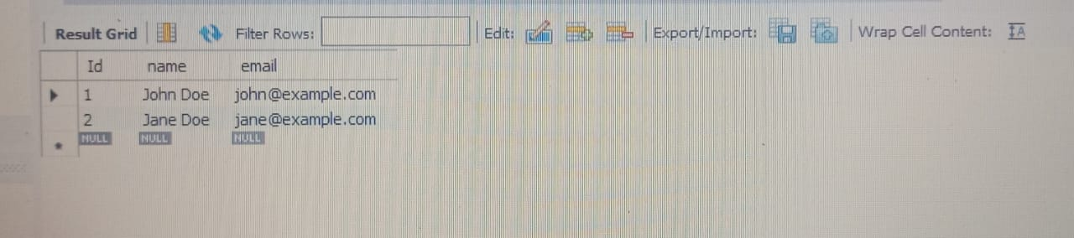

1. UPDATE employee SET email= “john2@example.COM” WHERE id=1;
2. DELETE FROM employee WHERE id=2;
3. SELECT * FROM employee;

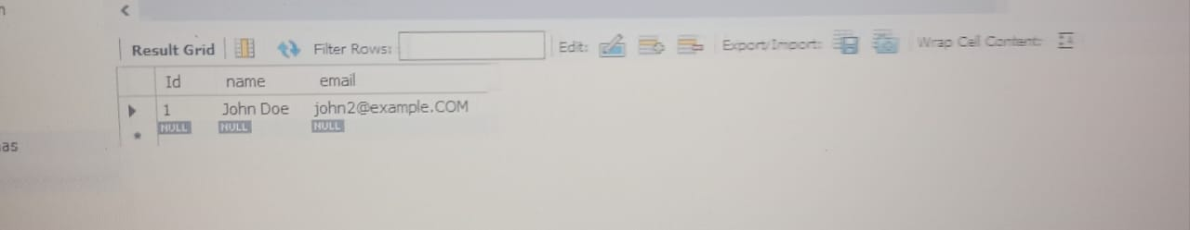

1. ALTER TABLE employee ADD COLUMN phone VARCHAR(100);
2. ALTER TABLE employee MODIFY COLUMN email VARCHAR(100);
4. INSERT INTO employee(id,name,email,phone)VALUES(3,”mahi”,”mahi@example.com”,”123-456-7890”);
5. SELECT * FROM employee;

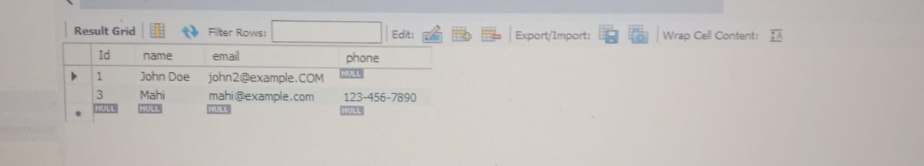

1. UPDATE employee SET phone=”345-764-1234” WHERE id=3;
2. SELECT * FROM employee;

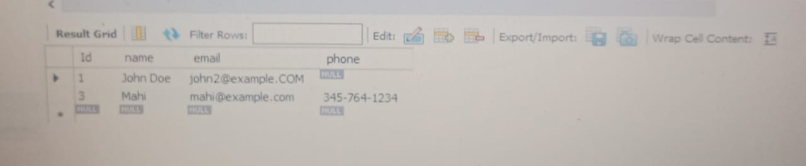

1. ALTER TABLE employee DROP COLUMN phone;
2. SELECT * FROM employee;

